Dear Ma’am/Sir

I’m writing this letter to express my interest in applying for the position of Computer Programmer I. I am Jimuel Z. Madrigal, 22 years old a graduate of BS Computer Engineering at Southern State University Lucban Quezon. I believe that my degree has prepared me for the said position. I was exposed and equipped with the necessary skills and knowledge to help me prepared for any work related problems that I might encounter in the future. In addition, I wish to bring my skills, knowledge and my commitment to excellence for this position.

I rendered my internship program at Pierre and Paul Solution Inc. During my On-The-Job training, I learned a lot especially in my soft skills. I learned how to collaborate with others, because before I used to work alone and rely only in myself, thinking the nature of the work I wish to enter being a team player is necessary skill. And I’m grateful that I developed it during my OJT. I also had the chance to be part of a project, which is the recruitment website of Pierre and Paul Solution Inc. and I am glad that we finished the project together with my partner.

For additional details regarding my qualification and expertise, please review my attached resume.

Thank you for taking the time to consider my application and I look forward to hearing from you.

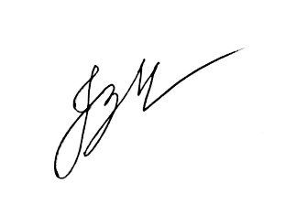

Sincerely,

Jimuel Z. Madrigal